Task 1: Design and Populate a Restaurant Database
Create a structured schema for a food delivery system and populate it with sample data using DDL and DML commands.
- Create a database named mealhub_db and a table named restaurants with columns: restaurant_id (INT, AUTO_INCREMENT, PRIMARY KEY), name (VARCHAR, NOT NULL), city (VARCHAR), cuisine_type (VARCHAR), and rating (DECIMAL(3,1)).
- Insert at least 6 restaurant records spanning at least 3 different cities.
- Update the rating of one restaurant and delete one restaurant record using a WHERE condition.
- Write a SELECT query that retrieves all restaurants sorted by rating in descending order.

CREATE DATABASE mealhub_db;

USE mealhub_db;

CREATE TABLE restaurants (
restaurant_id INT PRIMARY KEY AUTO_INCREMENT, name VARCHAR(100) NOT NULL,
city VARCHAR(100),
cuisine_type varchar(100),
rating DECIMAL(3,1));

INSERT INTO restaurants(name, city, cuisine_type, rating) VALUES ('Green Bowl','Vadodara','Healthy',4.2),
('Spice Route','Rajkot','North Indian',4.6),
('Ocean Pearl','Surat','Seafood',3.9),
('Urban Bites','Vadodara','Fast Food',4.8),

('Olive Garden','Jamnagar','Italian',4.7), ('Tandoori Tales','Bhavnagar','Punjabi',4.1);

UPDATE restaurants SET rating = 4.4 WHERE name = 'Ocean Pearl';

DELETE FROM restaurants WHERE name = 'Tandoori Tales';

SELECT * FROM restaurants ORDER BY rating DESC;

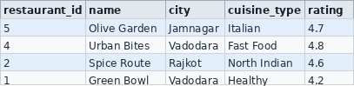

Task 2: Aggregate Revenue Reporting on Orders

Write SELECT queries using aggregate functions and GROUP BY to produce a restaurant-level revenue summary from order data.
- Create an orders table with columns: order_id, restaurant_id, customer_name, total_amount, and order_date.

CREATE TABLE orders (
order_id INT PRIMARY KEY AUTO_INCREMENT,
restaurant_id INT, customer_name VARCHAR(100), total_amount DECIMAL(10,2),

order_date DATE);

Insert at least 12 orders distributed across at least 4 restaurants.

INSERT INTO orders(restaurant_id, customer_name, total_amount, order_date) VALUES (1, 'Aarav', 1350.00, '2026-10-01'),
(2, 'Diya', 2100.00, '2026-10-02'),
(3, 'Kabir', 1600.00, '2026-10-03'),
(4, 'Mira', 2450.00, '2026-10-04'),
(1, 'Ishaan', 1750.00, '2026-10-05'),
(2, 'Anaya', 1900.00, '2026-10-06'),
(3, 'Vivaan', 2250.00, '2026-10-07'),
(4, 'Sara', 2800.00, '2026-10-08'),
(1, 'Reyansh', 2050.00, '2026-10-09'),
(2, 'Myra', 1550.00, '2026-10-10'),
(3, 'Arjun', 2400.00, '2026-10-11'),
(4, 'Kiara', 1950.00, '2026-10-12');

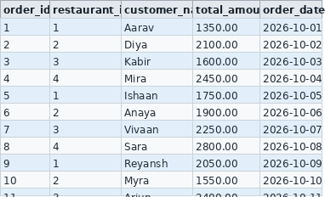

Write a query to show total revenue and average order value per restaurant.

SELECT restaurant_id, SUM(total_amount) AS total_revenue, ROUND(AVG(total_amount), 2) AS average_order_value FROM orders GROUP BY restaurant_id;

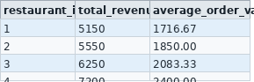

Write a query using HAVING to list only restaurants whose total revenue exceeds Rs 5,000.
SELECT restaurant_id, SUM(total_amount) AS total_revenue
FROM orders GROUP BY restaurant_id HAVING SUM(total_amount) > 5000;

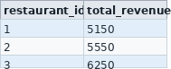

Write a query to retrieve the 5 most recent orders using ORDER BY and LIMIT.
SELECT * FROM orders ORDER BY order_date DESC LIMIT 5;
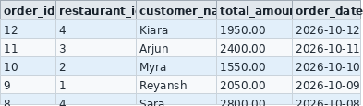

Task 3: Multi-Table JOINs and Menu Summary View

Build a two-table schema for restaurants and menu items, write JOIN queries to combine data, and create a summary VIEW.
- Create two tables: restaurants (restaurant_id, name, city) and menu_items (item_id, restaurant_id, item_name, price, category).

CREATE TABLE menu_items (
item_id INT PRIMARY KEY AUTO_INCREMENT,
restaurant_id INT, item_name VARCHAR(100), price DECIMAL(8,2),
category VARCHAR(50));

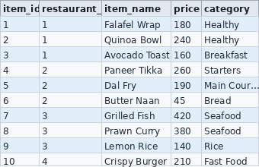

- Link them with a FOREIGN KEY on restaurant_id. Insert at least 5 restaurants and 12 menu items; at least one restaurant must have no menu items.

Write an INNER JOIN query listing restaurant name, item name, and price for all available items.
SELECT r.name AS restaurant_name, m.item_name, m.price
FROM restaurants r INNER JOIN menu_items m ON r.restaurant_id = m.restaurant_id;
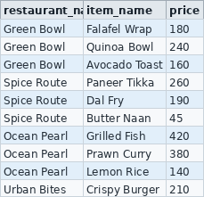

Write a LEFT JOIN query so that restaurants with no items also appear in results, with NULL values in item columns.

SELECT r.name AS restaurant_name, m.item_name, m.price, m.category
FROM restaurants r LEFT JOIN menu_items m ON r.restaurant_id = m.restaurant_id;

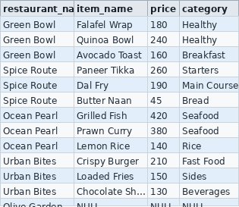
- Create a VIEW named restaurant_menu_summary showing restaurant name, total number of menu items, and average item price grouped by restaurant.

Task 4: PL/SQL Order Placement Procedure
Write a stored procedure to process a customer order with wallet deduction and full transaction control.

- Create a stored procedure named place_order that accepts customer_id, restaurant_id, and amount as parameters.
- Deduct the amount from the customer's wallet_balance in a customers table and insert a new record into the orders table.
- Use a transaction block: if the customer's wallet_balance is insufficient, ROLLBACK everything; otherwise COMMIT.
- Test with a valid order and an order exceeding wallet balance. Screenshot both outcomes from MySQL Workbench.

